Assumptions
Fabrikam Service Intelligence & Automation Architecture Challenge

Assessment: M4 Mock Assessment – 2

Assumptions Table :

Area | Assumptions
Infrastructure | Required cloud services are available
Data Schema | CRM case data schema is available
Access Permissions | Required permissions are granted
Security | Identity system is configured
Monitoring | Logs and telemetry are available

UserCase 1
User Story 1 – Advanced Operational Reporting Design

Objective:

Design a clear operational report for support managers to monitor active cases and SLA status.

Dataset Logic:

Case data includes Case ID, Status, Priority, Assigned Agent, SLA target, and resolution time.

Data is filtered to focus on active and recent cases.

Filters:

Date, Status, Priority, and Agent are provided to quickly narrow down results.

Report Layout:

Cases are grouped by Priority and Status to highlight high-risk items.

Summary information is shown at the top, with detailed case data below.

Drilldown Concept:

Managers can drill from priority level to individual case details.

Performance Optimization:

Pre-filtered datasets and limited visuals are used to improve report performance.

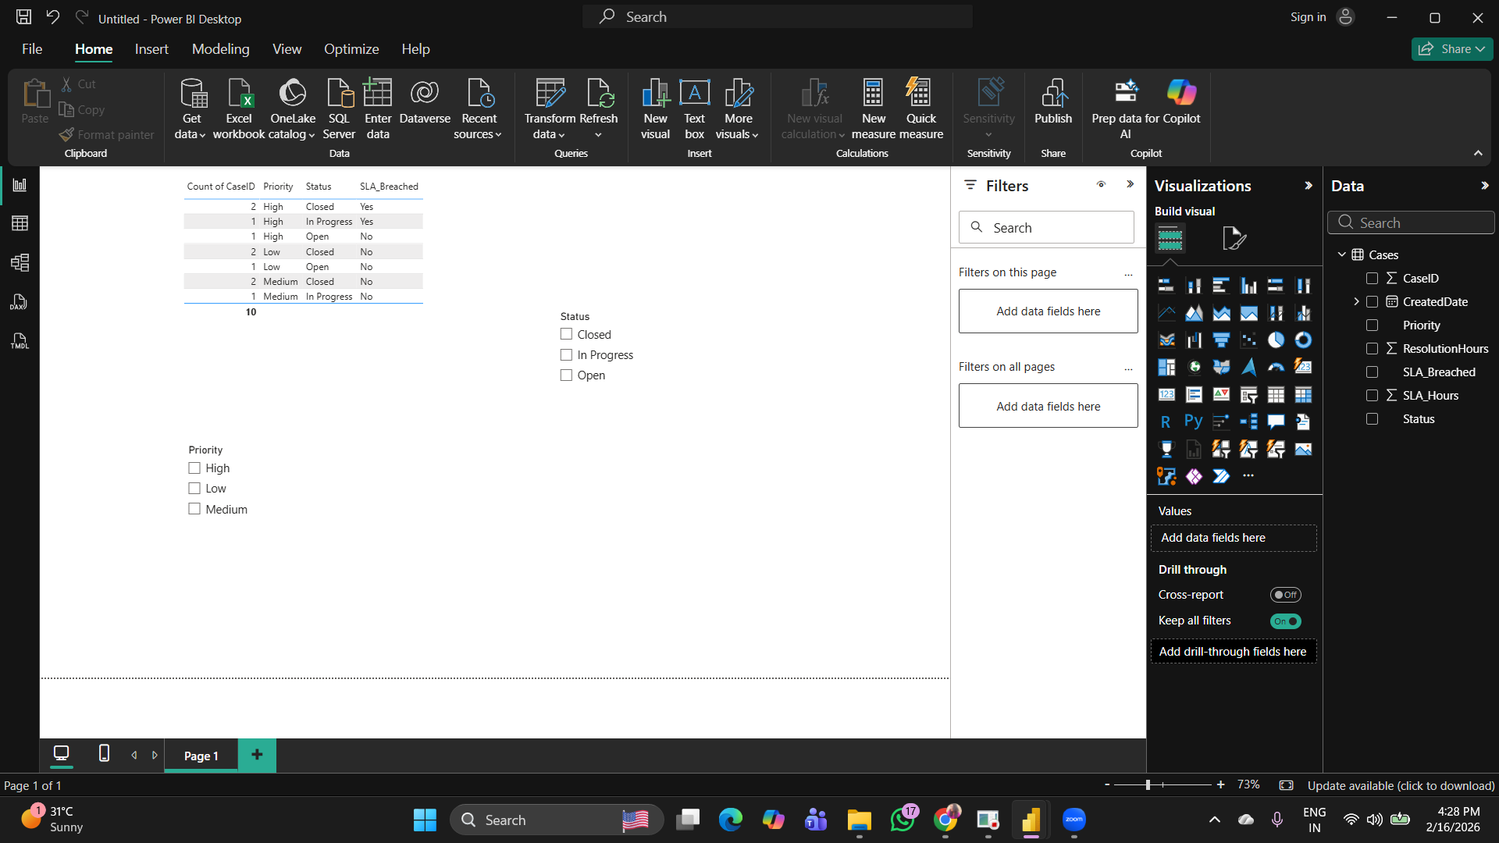

Figure: Operational Report showing case status and SLA monitoring

Usercase 2
User Story 2 – Executive Analytics Dashboard

Objective:

Provide leadership with high-level insights into case trends and SLA performance.

KPIs Used:

- Case volume trend to understand workload changes.
- SLA breach percentage to measure service quality.
- Average resolution time to track efficiency.
- Workload distribution by agent to balance resources.

Dashboard Layout:

Top section shows KPI cards.
Middle section shows trend charts.
Bottom section shows workload by agent.

Insights:

High-priority cases contribute more to SLA breaches.
Case volume increases during peak periods.

Business Decisions Enabled:

Better resource planning.
Early identification of SLA risks.

Limitations:

Insights are based on historical data.
Forecasting is trend-based, not predictive AI.

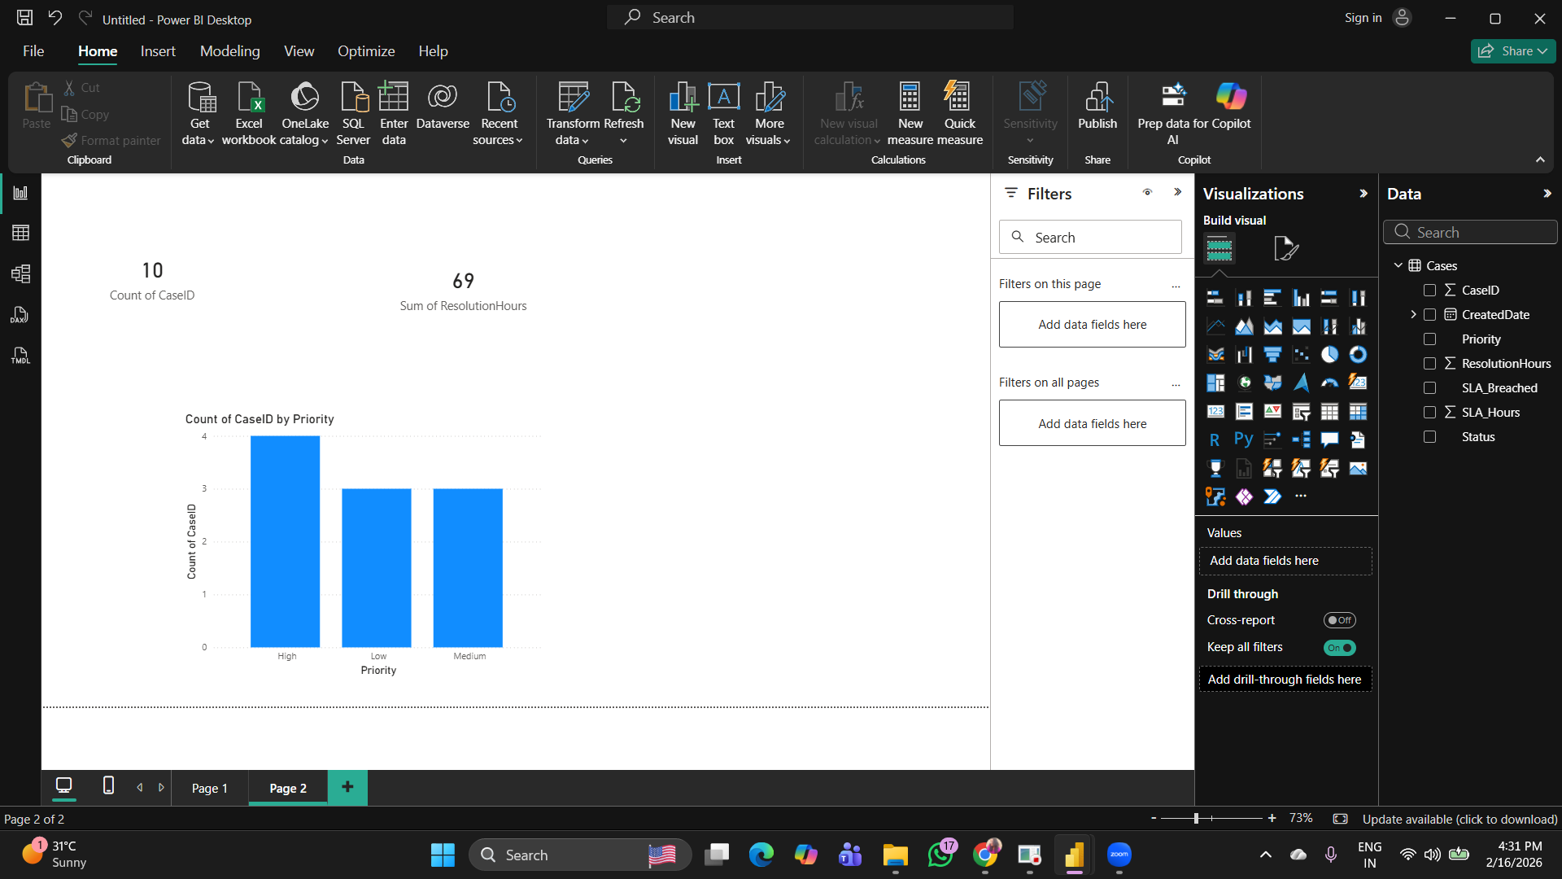 Executive dashboard showing SLA and case trends

UserCase 3

User Story 3 – Secure Distribution Architecture

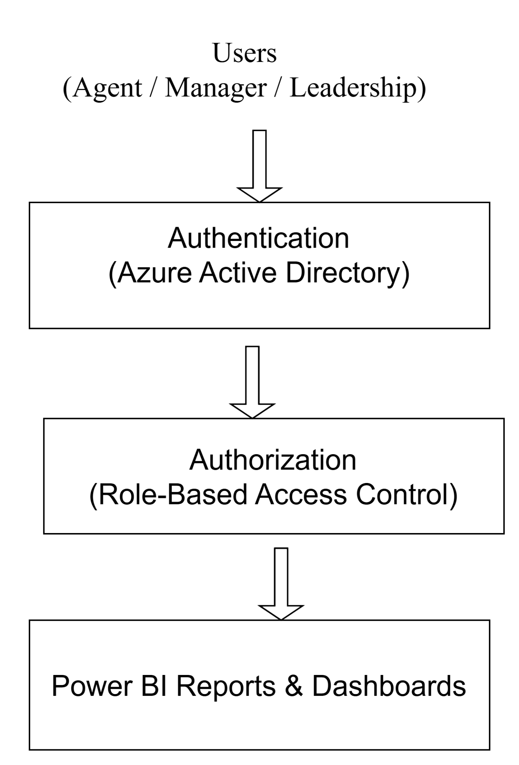

Secure access architecture showing authentication and role-based authorization

Authentication is used to verify user identity using Azure Active Directory.

Authorization controls what data a user can access based on assigned roles.

Agents can view only their own data.
Managers can view team-level data.
Leadership has access to all reports.

Reports are shared securely through role-based access control.
External users are provided limited, read-only access.

This approach prevents unauthorized access and protects sensitive data.

User case 4
User Story 4 – Intelligent Automation Workflow

Objective:

Automatically detect SLA risk for high-priority cases and notify stakeholders before breach.

Trigger Logic:

When a high-priority case is nearing its SLA threshold and the status is not Closed.

Workflow Logic:

The system checks SLA time for high-priority cases.
If the SLA threshold is close, an alert is triggered.
A notification is sent to the assigned manager.
If the case is still unresolved, escalation is sent to leadership.

Failure Handling:

If notification fails, the system retries up to three times.
All failures are logged for monitoring.
Admin is notified if repeated failures occur.

Tool Justification:

Automation platform is used to reduce manual monitoring.
Event-based triggers are chosen to control cost and improve efficiency.

Cost Awareness:

Automation runs only when conditions are met.
This avoids unnecessary processing and reduces cost.

Trigger → Condition → Action → Escalation
↓
Error Handling

Automation workflow for SLA risk detection and notification

User Case 5
User Story 5 – Storage Optimization Architecture

Objective:

Reduce CRM storage usage and cost caused by large file attachments.

Problem:

Storing large attachments directly in CRM increases storage cost and affects performance.

Solution:

Attachments are moved to external storage after case closure.
Only secure reference links are maintained in CRM.

Archival Logic:

Attachments for closed cases older than a defined period are archived automatically.

Performance Impact:

CRM performance improves due to reduced storage load.
Attachment retrieval remains available through secure links.

Cost vs Performance Trade-off:

External storage reduces cost significantly.
Slight delay in file access is acceptable for archived data.

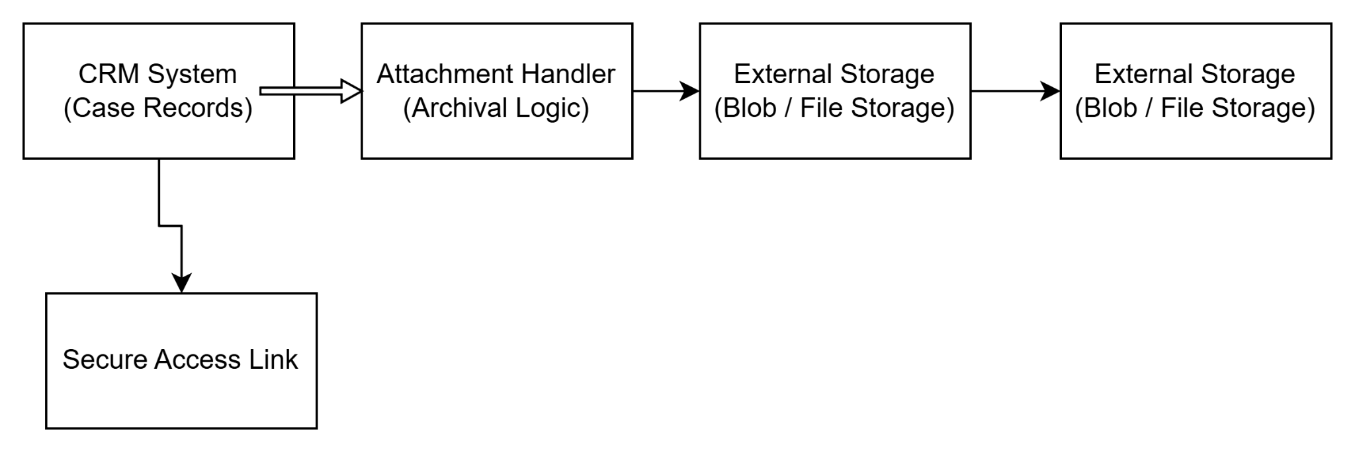

Figure: Architecture for attachment archival and storage optimization

Usercase 6
User Story 6 – Analytical Recommendation Report

Problem (Root Cause):
Manual monitoring of cases and lack of trend analysis lead to delayed SLA breach detection.

Metrics Used:
SLA breach percentage, average resolution time, and case volume trends are used to measure service performance.

Observations:
High-priority cases show a higher SLA breach rate.
Case volume increases during peak periods, impacting resolution time.

Risks:
Continued SLA breaches may result in penalties and customer dissatisfaction.
Increased workload without planning may reduce service quality.

Recommendations:
Introduce SLA alerts at 75% threshold to prevent breaches.
Plan staffing based on workload trends.
Focus more resources on high-priority cases.

Limitations:
Analysis is based on historical data.
Future trends may vary due to external factors.

